# Problem 1 – The Hungry Programmer

*You and your colleagues are on a teambuilding in the mountains. You have reached the closest mountain peak and now it is time to refresh with a meal. Unfortunately, the rest house is experiencing staff shortage so a helping hand with the serving is needed. You see an opportunity for abundant overeating and lend your help willingly.*

Write a JavaScript program to help you calculate how many meals have you managed to snatch from the kitchen without being seen. The input is an array of strings containing the portions of meals for serving and a series of commands. In case you receive the command "**Serve**", you must serve the last portion in the line, removing it from the array and printing on the console **"{meal name} served!"**. Upon receiving the "**Eat**" command, you must eat the first portion and print **"{meal name} eaten"** to the console. "**Add**" places the given portion at the beginning of the line. "**Consume**" – eat all portions in the given index range and print **"Burp!"** to the console. "**Shift**" – swap the portions at the given indexes. Upon receiving the command "**End**" the serving of plates is finished and you head over to consume your own portion of meal. Check if given indexes are **valid**.

The input consists of the commands **described** **above**, in the following format:

* Serve
* Add {meal}
* Shift {index} {index}
* Eat
* Consume {start index} {end index}

If a command does not match the pattern (unrecognized keyword, missing argument) it should be **ignored**.

**Input**

The input comes as two arrays. The **first** argument is an array of **strings**, containing **portions of meals**. The second argument is and array of **strings,** holding the **commands** that need to be parsed.

**Output**

On the **first line** print the remaining portions of meals in the array in the following format:

"Meals left: {meal1}, {meal2}, {meal3}, …"

In case there are **no meals left**, print **"The food is gone"**. On the **second line** print the number of the **eaten** meals in the following format:

**"Meals eaten: {count}"**

**Examples**

|  |  |
| --- | --- |
| **Input** | **Output** |
| ['chicken', 'steak', 'eggs'],  ['Serve',  'Eat',  'End',  'Consume 0 1'] | eggs served!  chicken eaten  Meals left: steak  Meals eaten: 1 |

|  |  |
| --- | --- |
| **Input** | **Output** |
| ['fries', 'fish', 'beer', 'chicken', 'beer', 'eggs'],  ['Add spaghetti',  'Shift 0 1',  'Consume 1 4',  'End'] | Burp!  Meals left: fries, beer, eggs  Meals eaten: 4 |

|  |  |
| --- | --- |
| **Input** | **Output** |
| ['carrots', 'apple', 'beet'],  ['Consume 0 2',  'End',] | Burp!  The food is gone  Meals eaten: 3 |

# Problem 2 – Expedition

*You are on an expedition in the mountains but the signs are pointing the wrong way and no one knows how to find you – so you're lost. It is getting dark already and you remember that you have an old map of the surrounding terrain in your backpack. To read it, first you've got to decode it. If you manage to figure out the way back to the rest house, you'll get there safely. Otherwise, you'll have to spend the night in the mountains and, as you know, the night is dark and full of terrors(bears).*

You have an **encrypted** map represented by a **rectangular** matrix (**primary**) with dimensions **N x M** and **random** values of **0** and **1**. An element of the matrix with **value 0** corresponds to a **path** and an element with **value 1** – to an **obstacle** that **cannot be crossed**. In addition to the primary matrix, there is another one – **secondary** rectangularmatrix, with dimensions **P x Q**. Its elements are also of **random** values (**0** and **1**). To be able to decode the map, you've got to overlay the secondary matrix on the primary matrix **n-times**. The coordinates of the element from the **primary** matrix, corresponding to the **upper-left** (**0, 0**) element of the **secondary** matrix, are received from the input. For example, if the received input is [1, 1] you have to place the upper-left (0,0) corner of the secondary matrix at 1, 1 of the primary matrix. Use the following modification criteria for **altering** **the** **primary** matrix:

* Element with **value** **1** from the **secondary** matrix **inverts** the value of the corresponding element in the **primary** matrix;
* Element with **value** **0** from the **secondary** matrix **doesn't** **change** the value of the corresponding element in the **primary** matrix;

When you're done with **all of the alterations** of the primary matrix you will get the **final** matrix. It represents the **deciphered** map of the terrain and you can use it to find your way back to the rest house. Your current location (**start**) is **always** going to be **on one of the four sides** of the matrix (**excluding the corners**) and the end will not be with the same coordinates as the start. You can only move **up**, **down**, **left** or **right**. At every moment, there will be **only one possible direction** to take, **if any**. In case you've come to a **dead end**, there is no way back and you've got to spend the night in the mountains.

### Input

You will receive four arguments – **primary** matrix, **secondary** matrix, **overlay** coordinates and **starting coordinates**. The overlay coordinates are an array of arrays, holding (x, y) coordinate pairs. The starting coordinates are also an (x, y) coordinate pair.

### Output

The first line of the output contains the number of steps made from the beginning to the end of the path. The starting point is the first step. Each cell of the matrix, holding value 0, corresponds to a single step. In case you find a way out, on the second line you must print "**Top**"/"**Bottom**"/"**Right**"/"**Left**", depending on that on which side of the matrix lies the exit (there won't be an exit in the corners of the matrix). If you've come to a dead end, you must print "**Dead end**", followed by a **quadrant number**,in which the end of the path is. See the examples below to understand how it works.



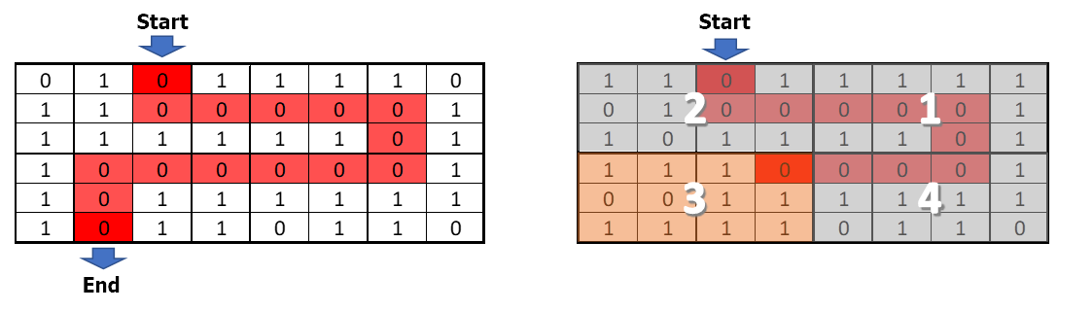

### Constraints

* The number of rows and columns of the primary matrix will always be an even number.

Scroll down for examples.

### Examples

|  |  |
| --- | --- |
| **Input** | **Output** |
| [[1, 1, 0, 1, 1, 1, 1, 0],  [0, 1, 1, 1, 0, 0, 0, 1],  [1, 0, 0, 1, 0, 0, 0, 1],  [0, 0, 0, 1, 1, 0, 0, 1],  [1, 0, 0, 1, 1, 1, 1, 1],  [1, 0, 1, 1, 0, 1, 0, 0]],  [[0, 1, 1],  [0, 1, 0],  [1, 1, 0]],  [[1, 1],  [2, 3],  [5, 3]],  [0, 2] | 15  Bottom |
| **Explanation** | |
|  | |

|  |  |
| --- | --- |
| **Input** | **Output** |
| [[1, 1, 0, 1],  [0, 1, 1, 0],  [0, 0, 1, 0],  [1, 0, 1, 0]],  [[0, 0, 1, 0, 1],  [1, 0, 0, 1, 1],  [1, 0, 1, 1, 1],  [1, 0, 1, 0, 1]],  [[0, 0],  [2, 1],  [1, 0]],  [2, 0] | 4  Dead end 1 |
| **Explanation** | |
|  | |

# Problem 3 – Lost in the Mountains

*The expedition is over and everyone has returned successfully to the rest house. It turns out, however, that one from the group has fallen behind. He has sent a message to the leader but his device is broken and his message contains unwanted symbols, which prevent it from being read. Since the leader does not understand anything from programming, he has assigned the task of decrypting to you.*

You will receive a text (**string**), which can contain **all of the ASCII symbols**, **including** **new lines** and **tabs**. The location of the lost person and his message must be retrieved from this string. The text contains a **keyword** that indicates the **beginning** and the **end** of the **message**. The geographical coordinates come as **a** **pair** of longitude ("**east**") and latitude ("**north**") and each coordinate should meet the following conditions:

1. It should start with "**north**"/"**east**", **case-insensitive**;
2. Next come **2 digits**, which form the **whole part of the degrees**;
3. The whole part of the degrees is separated from the decimal part by "**,**" and there may be any number of characters between them, **except** ","
4. The **decimal part** consists of **6 digits**

In case there is **more than one** longitude or latitude in the text, take **the latter**. The message is surrounded by the **keyword**, which will be the **first argument** from the input. The second argument from the input will be the **text**, containing **both the location** and **the message** of the lost person. See the examples below to understand how it works.

**Input**

The first argument contains the keyword and the second argument contains the text. There will always be **at least one pair of coordinates**.

**Output**

Print the latitude on the first line of the output in the following format:

**<*degrees*>.<*decimal part*> N**

On the second line of the output print the longitude in the following format:

**<*degrees*>.<*decimal part*> E**

On the last line print the message:

**Message: *<message>***

|  |
| --- |
| **Input** |
| <>  o u%&lu43t&^ftgv><nortH4276hrv756dcc, jytbu64574655k <>ThE sanDwich is iN the refrIGErator<>yl i75evEAsTer23,lfwe 987324tlblu6b |
| **Output** |
| 42.645746 N  23.987324 E  Message: ThE sanDwich is iN the refrIGErator |

|  |
| --- |
| **Input** |
| 4ds  eaSt 19,432567noRt north east 53,123456north 43,3213454dsNot all those who wander are lost.4dsnorth 47,874532 |
| **Output** |
| 47.874532 N  19.432567 E  Message: Not all those who wander are lost. |

Note there are three instances of north coordinates – the first two are ignored and only the last one is counted.